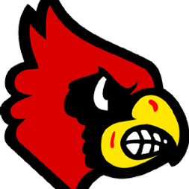 2023 Alton Boys Basketball Camp 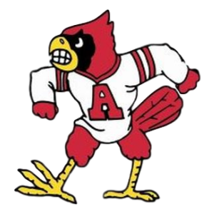
presented by: Alton Redbirds Basketball Staff and players

WHEN: June 5-8 WHERE: AHS Main Gym

WHO: Boys entering the following grades for the 2023/24 School Year:
Boys Entering 6th, 7th & 8th: 3:00 pm - 5:00 pm
Boys Entering 4th & 5th: 1:00 pm - 2:30 pm

COST: $25 per camper
- $20 for any additional brother attending camp
- Price of camp includes a t-shirt, basketball and all of the knowledge and fun that we can pack into the week.
- We will gladly accept walk-ups at any time during the week of camp.

The AHS Boys Basketball Camp will teach your child the fundamentals & individual skills of the game of basketball by the highly qualified coaches. Each day we will focus on giving your child the tools it takes to become the best basketball player he can become. He then needs to apply those skills and that knowledge on his own time to be the absolute best player he can possibly be.

Please cut off and fill out the below information & send with payment to the AHS Athletic Office or mail to:

Head Coach Dylan Dudley
AHS Boys Basketball
4200 Humbert Rd.
Alton, IL 62002

*Cash or Check written out to Alton High School

Camper _________________________________ Grade (2023/24 School Year) ________

Parent/Guardian _________________________________ Phone ______________________________

T-Shirt Size (circle one) S M L XL XXL

I hereby authorize the AHS Basketball Camp staff to act accordingly to their best judgment in any medical emergency and I hereby waive and release the said camp, its administrators, and Alton Schools from any and all liability regarding injuries or illness incurred to my child while participating in the camp. The cost for treatment of injuries or hospitalization for illness or injuries incurred during this camp will be the sole responsibility of the parent or guardian of the participant.
Parent/Guardian Signature___________________________________
Please note any medical condition that we should be aware of:

Camp Theme Days

*Kids should wear a t-shirt, jersey or socks according to each day’s theme.

**Kids are not required to dress according to the theme.

June 5 – Alton Redbirds Gear: Wear your favorite Alton Redbirds gear.

June 6 – Crazy Socks: Wear your favorite pair of crazy socks.

June 7 – Jersey Day: Wear your favorite jersey.

June 8 – Camp T-Shirt: Wear your camp t-shirt.

